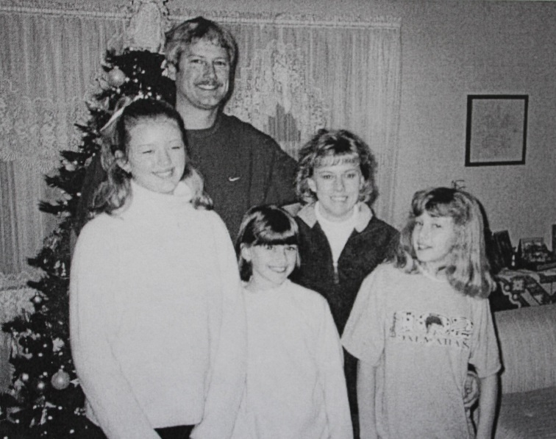

Dan and Jackie Snyder Raasch family: (l-r) Nikki, Dan (son of Don and

Dottie List Raasch), Brandi, Jackie and Krissy Raasch – about 1999 (est.)

**Mark Roger List and Jeanette Chapman List Family**

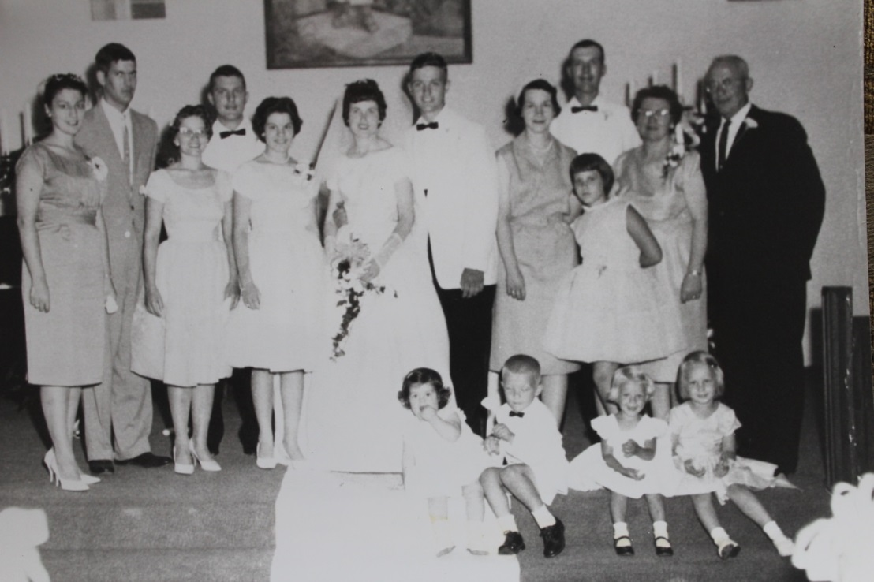

(l-r) Standing: Dorothy "Dottie” List Raasch, Don Raasch, Carolyn Huffer List, David List, Brenda List, Jeanette Chapman List (bride), Mark Roger List (groom), Jo Ann List, Ronald List, Susan List, Dorothy Wolfe List, Luther J. List; Seated (children): Debbie Raasch Brown, David J. List, Judith "Judie" List Sweeney, Ann List Link - 24 Jun 1962